ASSESSMENT WORKBOOK

Professional Studies II

This document will guide you through research, development and review of a series of standard policies and procedures used to manage an organisation and protect all stakeholders, including staff and clients/customers.

## Notes

Refer to the *Assessment Briefs* page in Canvas for a list of resources to assist in your research.

Review the AIE lectures to support your knowledge and information gathering.

# Preparation – *Review the Case Study*

* Read through the General Games Company Case Study’s materials available on Canvas:
  + Business Identity
  + Business Plan
  + Strategic Plan
  + Privacy Policy

There is a lot of information contain within these documents, although not all of it will be directly useful. Briefly read through the documents to identify what information is contained within each. Refer back to these documents as you complete the tasks in this workbook.

# Research & Identify Sources of Information

For these tasks you can refer to the list of websites listed on the *Assessment Briefs* page for this subject or refer to the lesson materials. You may also conduct your own internet research to gather the required information.

## Research IP Legislation & Resources

**Identify and document** *industry standard intellectual property (IP) legislation* *(e.g. Patent Act).*

List the Australian IP legislation that would apply to the *General Games Company*.  
Identify at list one piece of legislation, and the website where you can find it.

|  |  |
| --- | --- |
| Legislation: |  |
| Website: |  |

**Identify and document** at least 2 *industry standard IP websites* and *describe their use.* Examples include general information for businesses, online tools and submission portals.

|  |  |
| --- | --- |
| Website: |  |
| Description of Content/Use: |  |

|  |  |
| --- | --- |
| Website: |  |
| Description of Content/Use: |  |

## Research Copyright Legislation & Resources

**Identify and document** *industry standard copyright legislation (e.g. Copyright Act).*

List the Australian copyright legislation that would apply to the *General Games Company*.

|  |  |
| --- | --- |
| Legislation: |  |
| Website: |  |

**Identify and document** at least 2 *industry standard copyright websites*and *describe their use.* Examples include general information for businesses, templates for creating copyright policies/procedures.

|  |  |
| --- | --- |
| Website: |  |
| Description of Content/Use: |  |

|  |  |
| --- | --- |
| Website: |  |
| Description of Content/Use: |  |

## Research Privacy Policies

**Identify and document** at least 2 *existing privacy policies*.

Conduct some online research and identify 2 privacy policies of video game companies providing similar products/services to *General Games Company*.

Write a short description (2 to 3 sentences) that briefly describes the use of each policy, or highlights some key points within each the policy.

|  |  |
| --- | --- |
| Organisation: |  |
| Policy URL: |  |
| Description of Content/Use: |  |

|  |  |
| --- | --- |
| Organisation: |  |
| Website: |  |
| Description of Content/Use: |  |

# Intellectual Property and Non-Disclosure Agreements

Use the IP Contract Generator tool available on IP Australia (<https://www.ipaustralia.gov.au/understanding-ip/ip-contract-generator>) to **create an NDA contract** between your organisation and a contractor employed for service (for example, a sound engineer making music/sounds).

When using the tool, take into consideration the use cases of the business, as stated in the case study.

Copy and paste the final agreement below, or save a copy of the final agreement to upload with your workbook:

|  |
| --- |
| <TODO – Use the NDA Online Tool to generate the documentation. Include a copy of the final NDA with your workbook, and screenshots of the online portal here.> |

# Privacy Policy (Research)

Review the business plan for the case study to answer the following questions:

1. **List all** ***personally identifiable information*** (PII) collected by your organisation.

|  |
| --- |
|  |

1. **Describe** **why, what, when & how** your organisation uses the **PII**.

|  |
| --- |
|  |

1. **Describe potential risks** that may result from the misuse or unauthorised access of the personal information.

|  |
| --- |
|  |

# Privacy Policy

In the documents for the *General Games Company* case study you will find a *Privacy Policy*.

Use the *Privacy Policy Template* available on Canvas to update *General Games Company’s* privacy policy. Your final policy document should contain information from both these sources, along with other relevant information from the business plan.

You must ensure your final *Privacy Policy* covers all business practices proposed in the business plan, and aligns with industry standards.

|  |
| --- |
| <TODO – Complete Privacy Policy. This can be completed here, or as a separate document>  Example:  Policy Overview  This policy describes the personally identifiable information we collect, store and use as part of operations. It details why we collect the required information and how we utilise it.  Data we collect  We may collect information about you in several ways. The information we collect depends upon how you use our software, and includes any of the following:   * PII 1 * PII 2 * <TODO>   How we collect your data  GG Co collects email addresses upon sign-up to our services. We also collect usernames and optionally real names to link to account details.  How we store data  GG Co stores PII in encrypted databases store on our secured premised and backed-up to the following secure offsite cloud services <TODO>  How we use PII  GG Co uses email addresses for the sole purpose of <TODO>  How to access your PII  Customers can access their PII by logging into the system using their authorised credentials via the login page at <TODO>  How to lodge a complaint, request modification  Customer complaints and modifications to PII can be made by logging into the system using authorised credentials, or sending email to <TODO> |

# Code Of Ethics

**Find and modify** an *organisational Code of Ethics*, based upon industry standards, for the specific case study.

Research and select an existing *Code of Ethics*. The *Australian Computer Society* or the *International Game Developers Association* both have existing codes you may find appropriate.

You are to choose a *Code of Ethics*, and then make modifications to align the document with the business presented in the case study. Provide brief explanations where modifications were necessary to align the *Code of Ethics* with industry standards and organisational requirements.

Read the business objectives and products described in the business plan and consider any ethical challenges the company might face. Ensure the *Code of Ethics* can serve as a guide for the company when navigating potential ethical challenges.

Provide references for all sources used.

1. Write your final *Code of Ethics* here:

|  |
| --- |
| <TODO – Create your Code of Ethics. This can be completed here, or as a separate document>  Example:  As a Game Development Studio, we will be honest and ethical wherever we operate in the world. We will adhere to the code of ethics herein and uphold the values of Openness, Courage, Respect, Focus, and Commitment.   1. Public Interest is of the highest importance. We will place interest of public above our own personal & business interests. 2. We will be honest in all interactions and representations of product, services, skills, technical potential. 3. TODO 4. TODO 5. TODO 6. TODO 7. TODO |

1. List the original *Code of Ethics* document used:  
   (If more than one document was referenced, add additional rows)

|  |  |
| --- | --- |
| Organisation: |  |
| Code of Ethics URL: |  |

1. Explain where modifications were made, and why these were necessary or appropriate:

|  |
| --- |
|  |

# Grievance Policy

Grievance policies and procedures are designed to manage the complaints or grievances within the organisation in relation to the application of the code of ethics.

**Create** an *Employee Grievance Policy*, based upon industry standards, for the *General Games Company*.

Explore the below resources and use this information when documenting your grievance policy. Ensure you reference all sources used.

**Employee Grievance Procedures – template:**

<https://resources.workable.com/grievance-procedure>

**Vic guidelines for Dispute Resolution:**

<https://www.business.vic.gov.au/disputes-disasters-and-succession-planning/dispute-resolution>

**NSW Anti-Discrimination - Making a Complaint:**

<https://www.antidiscrimination.justice.nsw.gov.au/Pages/adb1_makingacomplaint/adb1_makingacomplaint.aspx>

|  |
| --- |
| <TODO – Complete Grievance Policy. This can be completed here, or as a separate document>  Example:  Policy Overview  Our grievance procedure policy explains how employees can voice their complaints in a constructive way. Supervisors and senior management should know everything that annoys employees or hinders their work, so they can resolve it as quickly as possible. Employees should be able to follow a fair grievance procedure to be heard and avoid conflicts.  Definition of employee grievances  Employee grievances include:   * Item 1 * <TODO>   How we collect & record employee grievances:  <TODO>  Employees who file grievances have the right to:   * Receive a copy of the allegations against them * Respond to the allegations * Appeal on any formal decision   The organisation is obliged to:   * Have formal grievance procedure in place & communicate procedures to all stakeholders * Investigate all grievances promptly * Treat all employees who file grievances equally * Preserve confidentiality at any stage of the process * Resolve all grievances when possible * Respect its no-retaliation policy when employees file grievances   Follow-up procedure after grievance is made   * Employee is contacted immediately via direct supervisor. * Grievance is evaluated by supervisor, and relevant personnel tasked to resolve - this may include staff members, community managers, lawyers as appropriate. * If grievance directly involves supervisor, then HR personnel is tasked with evaluation * Provide the employee who faces allegations with a copy of the grievance * Organize mediation procedures (e.g. arranging a formal meeting) * Investigate the matter or ask the help of an investigator when needed * Keep employees informed throughout the process * Communicate the formal decision to all employees involved * Take actions to ensure the formal decision is adhered to * Deal with appeals by gathering more information and investigating further * Keep accurate records |

# Cyber Security Policy

## Research Cyber Security Threats & Stakeholder Knowledge

1. **Identify and document** at least 5 *cyber security threats*to your organisation. Examples include Malware, Phishing Emails, etc.   
     
   **Describe how they can harm** your organisation, employees and/or customers/clients.   
     
   Also **describe the level of awareness** your *employees* and *customers* have against each threat.

|  |  |
| --- | --- |
| Threat: |  |
| Description of harm to organisation: |  |
| Level of organisational awareness required |  |
| References or URLs: |  |

|  |  |
| --- | --- |
| Threat: |  |
| Description of harm to organisation: |  |
| Level of organisational awareness required |  |
| References or URLs: |  |

|  |  |
| --- | --- |
| Threat: |  |
| Description of harm to organisation: |  |
| Level of organisational awareness required |  |
| References or URLs: |  |

|  |  |
| --- | --- |
| Threat: |  |
| Description of harm to organisation: |  |
| Level of organisational awareness required |  |
| References or URLs: |  |

|  |  |
| --- | --- |
| Threat: |  |
| Description of harm to organisation: |  |
| Level of organisational awareness required |  |
| References or URLs: |  |

1. **Create** your *organisation’s ICT Security Policy*, based upon industry standards, for your specific case study. Include consideration for all stakeholders.  
     
   Download the “Cyber Security Policy.docx” example from Canvas. Other examples are also available on Canvas on the *Assessment Briefs* page.   
     
   Use the example policy as a guide, filling in the blanks and adding additional detail to ensure the final policy aligns with the business plan from the case study,

|  |
| --- |
| <TODO – Complete ICT Security Policy. This can be completed here, or as a separate document>  Example:  Policy Overview  Our company cyber security policy outlines our guidelines and provisions for preserving the security of our data and technology infrastructure.  The more we rely on technology to collect, store, and manage information, the more vulnerable we become to severe security breaches. Human errors, hacker attacks and system malfunctions could cause great financial damage and may jeopardize our company’s reputation.  For this reason, we have implemented several security measures. We have also prepared instructions that may help mitigate security risks. We have outlined both provisions in this policy.  This policy applies to all our employees, contractors, volunteers, and anyone who has permanent or temporary access to our systems and hardware.  … |

# ICT Strategy – Gap Analysis & Work Breakdown Structure

## Research ICT potential technical problems

**Identify and record** at least 5 *technical problems*that your organisation may face when enacting its strategic plan. Describe how they can harm your organisation, employees and/or customers/clients. Examples include security risks, network communication issues, compatibility issues. Review the AIE lectures for more examples.

|  |  |
| --- | --- |
| Problem: |  |
| Description: |  |

|  |  |
| --- | --- |
| Problem: |  |
| Description: |  |

|  |  |
| --- | --- |
| Problem: |  |
| Description: |  |

|  |  |
| --- | --- |
| Problem: |  |
| Description: |  |

|  |  |
| --- | --- |
| Problem: |  |
| Description: |  |

Critical analysis of your current ICT systems will guide your team in developing a solid action plan on how to meet the Strategic direction of the organisation.

This will require an evaluation of the organisation’s current ICT systems.

In this section, you will perform a **gap analysis** to determine what gaps must be addressed by any proposed ICT changes. **Alternate options** can be proposed. Use tools like a **cost-benefit** analysis to compare proposed solutions and select final recommendations.

For the purposes of this exercise, if the case study documents do not provide detail regarding specific ICT infrastructure currently in use, you can assume that either the resources do not exist or are the bare minimum required to perform work tasks.

1. Download & complete the “*ICT-Gap-Analysis-Template*” spreadsheet available for download from Canvas. Complete both the *hardware* and *software* sheets.
   1. *Refer to the Case Study documentation* to complete this document. Brainstorm details about your proposed business as you go.
   2. A screenshot of the template document is provided below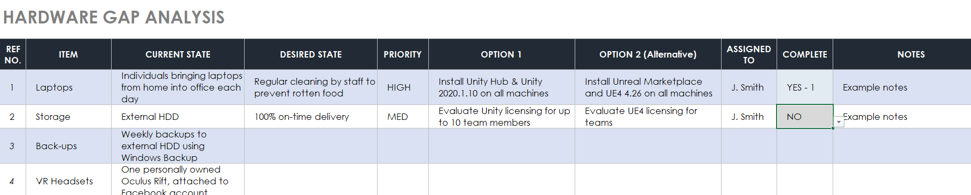
2. Finally, download & complete the “*ICT-Work-Breakdown-Structure-Template*” MS Word document (or alternatively use online tools like diagrams.net) to document your final proposals in a **Work Breakdown Structure** detailing all the individual elements that need to be completed, considering the priorities and dependencies of each task.
   1. A screenshot of the template document is provided below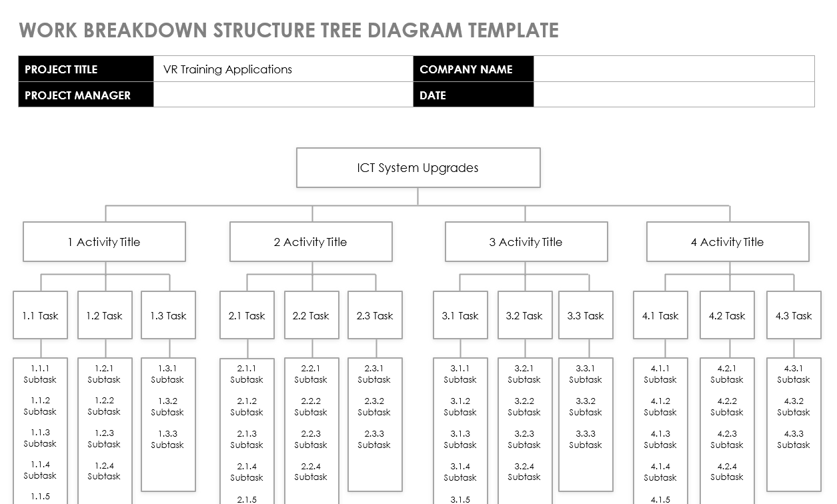

# Review of Policies

As you complete this workbook, record any instances where you discussed your work with your trainer, assessor, classmates, or others.

Discussions you could list here include (but are not limited to):

* Asking your instructor/assessor for feedback on specific answers
* Asking your instructor/assessor for clarification on specific tasks
* Discussing specific policies or questions with classmates
* Hearing about an online resource from a classmate
* Feedback from your assessor regarding an *NYC* submission

Describe any changes you made to any work tasks because of these discussions.

Record details of at least two of these interactions.

|  |  |
| --- | --- |
| Topic of Discussion: |  |
| Date: |  |
| Names of discussion participants: |  |
| Discussion description: |  |
| Resultant actions: |  |

|  |  |
| --- | --- |
| Topic of Discussion: |  |
| Date: |  |
| Names of discussion participants: |  |
| Discussion description: |  |
| Resultant actions: |  |